Practical Week 8
Topology
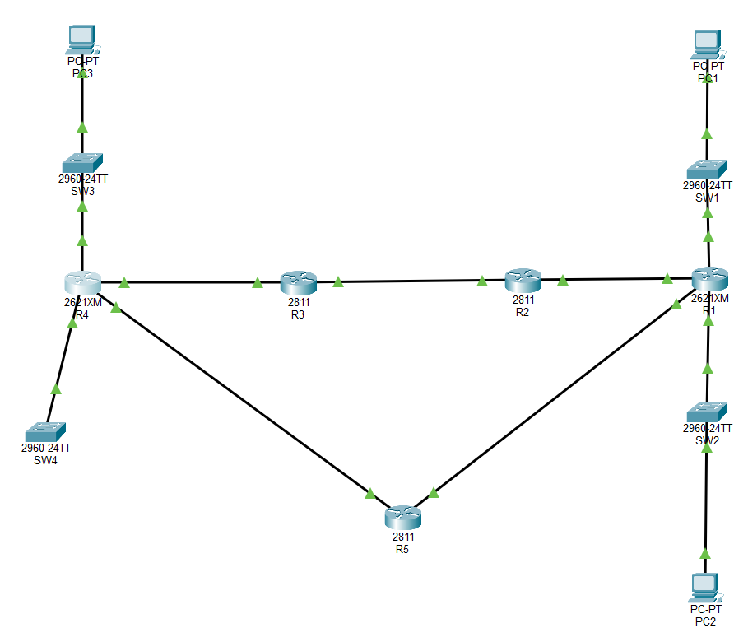
Task 74
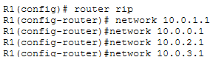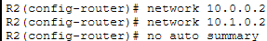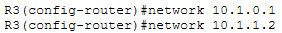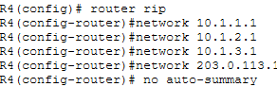
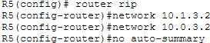
Task 75
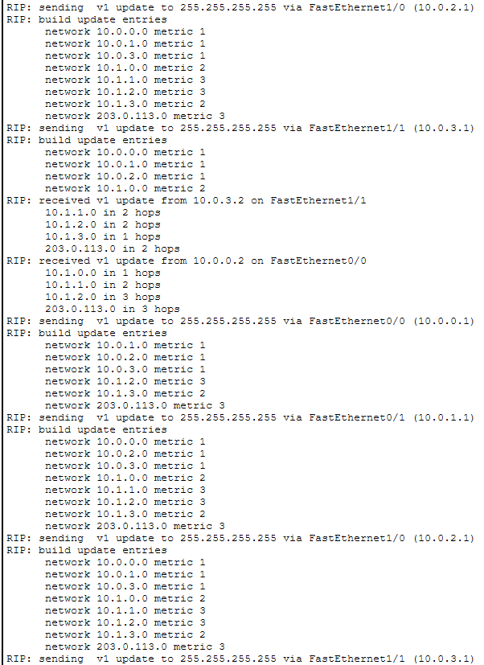
Task 76
Task 77
Task 78
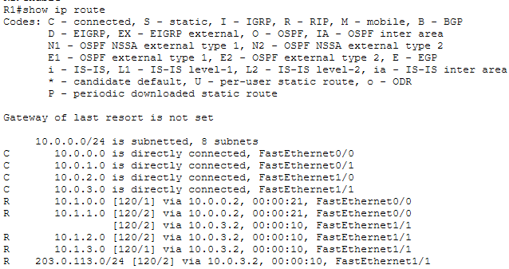
Task 79
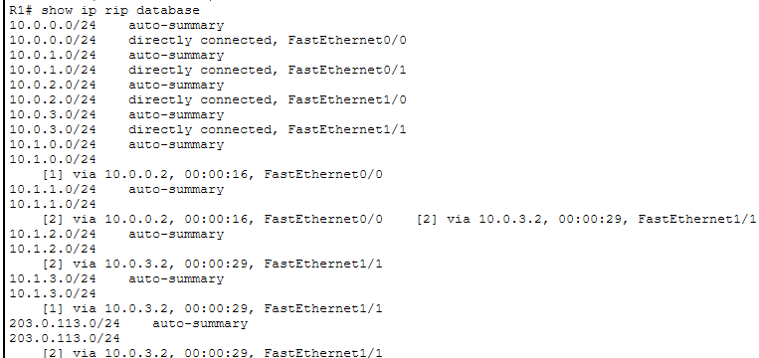
Task 80
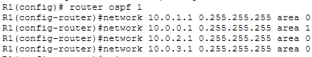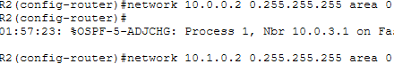
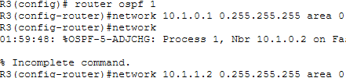
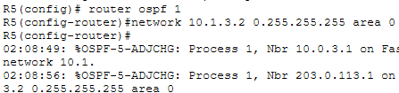
Task 81
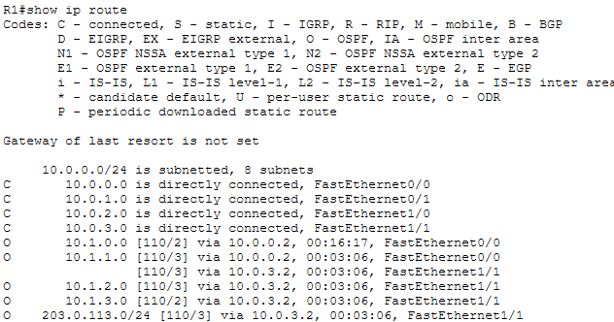
Task 82
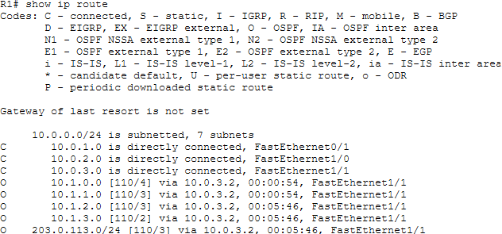
Task 83
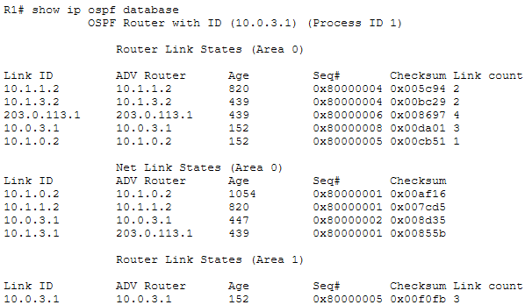
Task 84
It uses multicast traffic.
Task 85
So that they could be connected to the OSPF at the same time.
Task 86
They are still present because they are permanently there.
Task 87
The other address from the 10.1.1.0 route is absent
Task 88
RIP database does not support VLSM while OSPF supports VLSM

